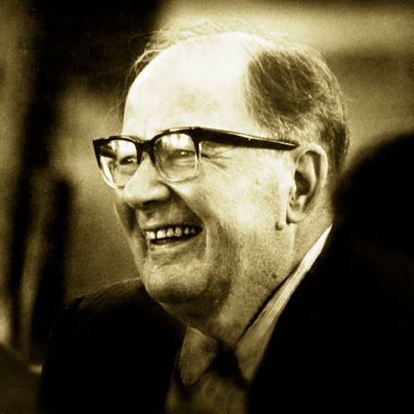

# Holy Cross Retreat Center

# Mesilla, NM

# Friday - Sunday, 6-8 October 2017

The retreat will be guided by Fr. Robert Dueweke, OSA, and the Hesed Team (Jean Soto, Gloria Hofer, and Jack Mooney). Cost: $60; Meals are extra. (Scholarships available) Contact Gabby Martinez for details.

[gabby.mtz5@gmail.com](mailto:gabby.mtz5@gmail.com) 915-630-9151

The Human Good

Lonergan IV Retreat

**REGISTRATION FORM**

**NAME ___________________________**

**Email ____________________________**

**PAYMENT ($60; Scholarships available) ______________**

**Meals**

**Saturday (Oct. 7)**

**Breakfast ($7) ___**

**Lunch ($9) ___**

**Dinner ($10) ___**

**Sunday (Oct. 8)**

**Breakfast ($7) ___**

**Lunch ($9) ___**

**Lodging**

**Make your own arrangements with Holy Cross Retreat Center.**

**(575) 524-3688**

**Note:** Bring snacks and drink to share on Saturday evening.

**Schedule**

**Friday (Oct. 6)**

**7 - 9 PM** Gathering and Conference 1

**Night Meditation:** Read Chapter 1 of Colossians. How is the whole universe a “common good”?

**Saturday (Oct. 7)**

**TBA** Breakfast

**9:15 AM** Opening Prayer and Conference

**TBA** Lunch

**1 - 2 PM** Personal Time

**2 - 4 PM** Conference

**TBA** Dinner

**7:30 - 8:30 PM** Discussion with refreshments

**Night Meditation:** Reflect on how 1 Cor. 12:12-26 helps us understand the human good in our society today.

**Sunday (Oct. 9)**

**TBA** Breakfast

**9:15 AM** Morning Prayer and Conference

**11 AM** Eucharist (shared homily)

**12 PM** Lunch and departure