2016 Reflections on the Triduum
Robert Dueweke, O.S.A.

The purpose for this reflection guide is to shed light or new interpretations on words and phrases used throughout the season of Holy Week and specifically the three days called the Triduum (Holy Thursday, Good Friday, the Easter Vigil on Saturday night). If the terms are understood, then the relationships between them will provide new insights for connections with ordinary life on the personal, national, and global levels. Terms and phrases are embedded in symbols, which are ‘carriers of meaning and value.’ A symbol is something, an object, which holds the fragments of life experiences together in a way that makes sense. Some symbols worthy of reflection are cross, bread, wine, water, oil, and fire. Christianity has something credible to say to the world when terms and symbols are understood, but assumptions need to be examined first. The first place to begin is with the terms and what they signify.

The season of Lent officially ends with the beginning of the Holy Thursday liturgy in the evening. The notion of the Lenten fast changes in tone from ‘penitential’ to one in “preparation for” entry into the Triduum, the most important days of the Liturgical Calendar of the Church. The rhythm of these three days is repeated every Sunday. This is so important that 50 days after Easter Sunday is celebrated “as though it were one Sunday.” This period of 50 days is also called the time of mystagogia – which implies a time of teaching and breaking open the mysteries of the faith we have just celebrated. It reviews what has happened and attempts to make the connections of what this ‘new life’ is all about.

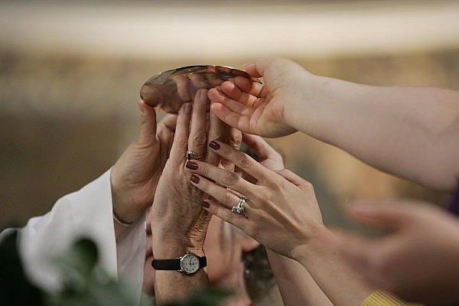
HOLY THURSDAY
Key terms: Last Supper, Eucharist, Washing of feet, an alternative reality

In the context of a supper, Jesus leaves his legacy with the apostles in the ritual action of washing feet. The summary of his entire mission in proclaiming the reign of God is in the new commandment: love one another as I have loved you. For Jesus, table fellowship is the symbol of an alternative reality that is possible. Integral to this reality is the commitment to serve. This is Jesus’ “mandate” to those who want to be a part of his movement and join in his project.

A question from a Facebook post: What is Maundy Thursday?
Answer: Maundy Thursday = Holy Thursday. "Maundy" is an old English term that comes from the Latin "mandatum," which means "command, orders." At the Last Supper, Jesus gives the command to wash feet, to love one another. This is the new commandment. See https://en.m.wikipedia.org/wiki/Maundy_Thursday

From time to time, we should reflect on what it means to share a meal. Do we notice the difference between sharing a home-cooked meal and one eating alone in a fast food restaurant? A meal, like a supper, is a social reality. In the sharing of food there is a sharing of lives, hopes, desires, joy, challenges. A good practice for Lent is when each family commits itself to share a meal together at least once a week! All know too well that the pace of modern living prevents many from spending time together sharing a meal. If one does not experience the practice of having supper together on a regular basis, the idea of Eucharist and what is celebrated will be incomprehensible.

The institution of the Eucharist (which means “thanksgiving”) has its roots in the Last Supper. Over the centuries the way Eucharist was celebrated changed as the assemblies continued to grow and as self-understanding modified itself in the varying historical contexts. Central to the Eucharist is the body and blood of Christ. There are two important points about this expression. First, the notion of “body.” The expression “Christ’s body” can be understood in three ways: the historical body of Jesus the Nazarene who walked the earth, the “sacramental” body celebrated at Eucharist, and finally the body of the “whole Christ,” which is the “body” of humanity together, in flesh and blood. The least understood is the “whole Christ,” that layer of humanity stretched across the surface of the planet. Christ’s “body” reflects something about the world “body” of humankind.

The next point is the understanding of what we mean by the “body and blood of Christ” as celebrated in the Eucharist. Bread and wine represent the sacramental part of the mystery of transformation. Bread represents the best of humanity, its creative capacity to make change toward the better. Bread – a process of growing grain, processing it and baking it to satisfy physical hunger. It is an action of creativity; the human being participates in the ongoing shaping of the world as co-creator with God Creator.

The wine represents the many forms of violence committed by human beings. It is the tendency towards communal suicide. As the world becomes more interconnected and global in its relations, violence tends to become systemic. Corrupt economic and political systems engender violence that ripple across the globe. Lent is a time to critically reflect on systemic sin. Faulty thinking, influenced by personal, group, and cultural biases, promotes a kind of violence.

At the Eucharist, the consecration of bread and wine is the consecration of the body and blood of Christ, the body and blood of the “whole” Christ – the human dimension living on the planet! Bread and wine, body and blood, the best of human development and the violence committed against one another, are all “lifted up” for transformation of a better world. This is consecration. As symbolized in the bread, the human has great potential, for it is created in the “image of God.” And yet, because of freedom, one has the choice to recognize in the other as friend or foe. The question is: What shape or condition is the “body” of the whole Christ? Good Friday opens the door to the answer.

GOOD FRIDAY
Key words: Cross, execution, humanity, brokenness
(Facebook posts) People say that Christianity is no longer relevant in our world; it has nothing to say to personal meaning or to world violence. I am always meeting people, young and old, who say they are no longer Catholic, Christian, religious, or spiritual. People are leaving traditional religion; the 20-45 year old group are gone. And the Church says very little about this phenomenon. What I observe is that the religious symbols are no longer connected to real human, ordinary experiences. As long as the symbols are disconnected from life, Christianity and its symbols will be empty of meaning.
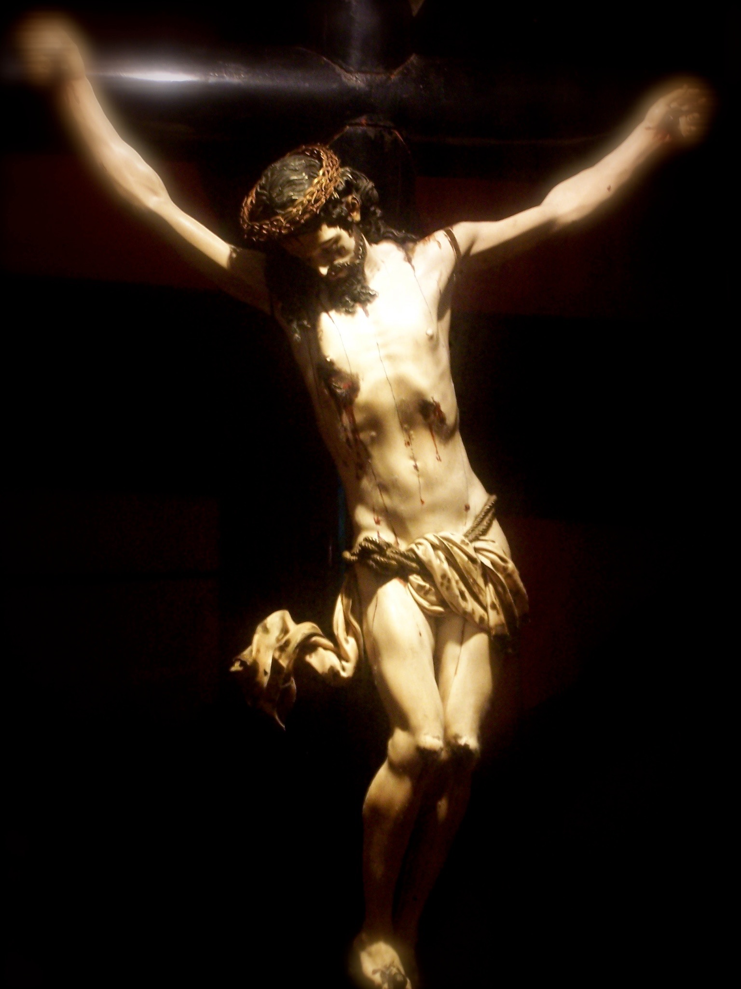
The core of Christianity is wrapped up in these three days called the Triduum: Holy Thursday, Good Friday, and Easter Vigil (Saturday night). One misconception the needs to be clear immediately is the popular belief that "Christianity = the Vatican." It does not. As St. John (3:16) says, "God so loved the world he sent his Son," not the Church! Jesus came with a message about the reign of God. The Church is established as a vehicle to carry that message and to preach it. But many times it has taken detours with serious consequences in history. That core message of the reign of God is embedded in these three, sacred days.
Today we experience our world in high alert. We are more conscious of world violence. The Brussels attacks last week remind us of how the world has perceptively changed. I was in Rome last month and noticed the increased security and structures of crowd control around St. Peter’s. There isn’t the freedom of movement as there once was. The political tone in this country has something toxic in the air; things are different. People are threatened by political rhetoric. Yet, we need to respond and we have no lack of "voices": military, diplomatic, or just ignore it. In this political cacophony, Christianity has its own voice and the core message is in the Triduum, the high point of the Church year.
GOOD FRIDAY: What is it about, really? Is it just a commemoration of an historical event or is it a commentary on our reality today? To say "Jesus died for our sins" is more that what is popularly believed, as a sort of "ticket" into heaven. It has deeper meaning and connections.
Good Friday has other dimensions: it is the point where economics and politics-- those dimensions that secure the delivery system for the necessities of life in any society--intersect with faith. The Cross is the "voice" -- a Christian symbol of violence, from the domestic to the global. It is not just a symbol, however, it is a "question mark" to all of us: What is our response to violence, from hateful speech, the lie and contempt for truth to terrorism? The Cross interrogates our minds and hearts and asks for a response. If the Cross is the "question," what is the "answer"? If Christianity has no "answer" to world violence, then it shouldn't exist. (Hint: What is Holy Thursday all about?)
A post from someone on Facebook: Some non Catholic Christians have asked why we (Catholics) display the image of Christ’s body on the cross not just Good Friday/Holy Week but all throughout the year? Why not just a simple cross?
Answer to the post:
Good question. The cross is an instrument of execution for criminals. The image of Jesus' body on the cross is a narrative about one particular execution. Also, for Catholics, with the Eucharist as central to its spirituality, the body of Jesus on the cross relates to the body of Christ celebrated as sacrament. For Catholics, we understand the "body" of Christ in its different dimensions. The most common are the historical body of Jesus who walked the planet 2000 years ago. And second, the "sacramental" body on the altar as Eucharist. But there is a third type that is often forgotten: the body of the "whole Christ." The whole Christ is the "body" of the mass of humanity stretched across the globe, and that body is a tortured and crucified body (due to hunger, poverty, war, etc.) Mt. 25: "Whatever you do to the least of my brothers and sisters, you have DONE TO ME."
A contemporary Good Friday:
Srebrenica 1995 is "Good Friday" in our contemporary world.
http://nyti.ms/1RntYGl

***
HOLY SATURDAY
Key words: Contemplative quiet, silence, presence – not absence, inquiry, summary
Holy Saturday has a quality of silence that makes it a unique day in the Triduum. The silence is not an absence, but a presence, like a human body in the tomb. The silence is a "space" to ask and answer questions. A friend wrote me today and asked why did Jesus die on the cross? Why the Eucharist of Holy Thursday? What are the connections? Where are the insights? For many, this season is about rabbits, eggs, and the rites of Spring. Secular society speaks nothing Christian; it is purely commercial, and empty of meaning. Ask anyone why chocolate rabbits and colored eggs? We do things and do not know why. Maybe it is good for the kids. Maybe it is good for capitalism. Easter says nothing about the voices of Trump or Hillary.
Summary of events – invitation to shift attitudes
To have clarity on these Christian mysteries, we need to review the terms and their relations. The Cross of Good Friday: a structure for execution of criminals. Jesus was a rebel: he ate at table with prostitutes and sinners; he talked to women in the public square; he personalized God by using the word "Father;" he attacked the finance office of the Temple - one of the 3 crimes that merited capital punishment. Innocent, he was executed. This is why Jesus was executed. He called people to a higher ground or viewpoint, beyond rules and regulations. The higher ground or viewpoint implies a shift on how we question, evaluate, choose, decide and act. This shift affects one’s horizon, or the scope on what one holds as value and important. The Triduum is an attempt to ‘shift’ to the higher ground and therefore change horizons that are more open, forgiving, compassionate, loving, and human.
The Table of Holy Thursday as a higher viewpoint: a gathering around the table to dialogue, participate, provoke, discuss, challenge, reconcile, grieve, cry, celebrate, to be with. Washing feet, bread, wine, scriptures - elements around the table. The gathering "pretends" to be one, in unity, in community; it "pretends" to like the person next to the other. The table is the higher viewpoint that the person matters and from which to critique the status quo.
Cross and Table::Violent reality/alternative reality::question/answer.
The Good Friday Cross is the expression of all that makes up world violence. How many innocent ones die? How many innocents are forced to migrate and the "Pilates" of nations condemn them? Why are people fleeing? What are the root causes? Why ISIS? Why human trafficking? To what is it a response?
The Holy Thursday Table: "Am I my brother's and sister's guardian?" (Gen. 4:9). The alternative reality says "yes!" The alternative reality believes the body of Christ = body of humanity, stretched across the surface of the planet, a body of broken bones and blunted nerve endings. The bread = all that is best in the human; the wine = all that is violent in the human. Transformed bread and wine = transformed for a world more human ... the deepest desire and aspiration ... the scheme of recurrence called 'Eucharist.' What is a “scheme of recurrence”? A ‘scheme’ is that which is repeated and forms a pattern. For Catholics, participating at Mass every Sunday is a “scheme of recurrence,” a repetition. The daily practice on a violin or piano is a ‘scheme.’ Daily prayer is a scheme. Something new can emerge from a scheme. It might be an insight or a discovery: fire, electricity, theory of relativity, decision to live in a certain way, a vocation to helping others. “Do this in my memory” is an invitation to begin a “scheme of recurrence” so that something new can emerge when there is a shift. The ‘shift’ is another way of speaking about “conversion.”
We move from the cold ashes that marked the beginning of Lent to the fire of the Easter Vigil on Saturday evening. The Triduum is a spiritual ignition, a crack of thunder, a radical insight in the mind for a new vision for the people. Is it political? You bet. When believers begin to understand and make the connections that these holy days symbolize, watch out Mr. Trump and Mrs. Clinton! Easter is about hope from despair and trust in the human good. So much for rabbits laying eggs.
***

THE EASTER VIGIL
Key words: fire in the darkness, memory, baptism, Eucharist, joy, conviction, new energy

(A Facebook post) I experienced something for the first time tonight at the Easter vigil in this New Hampshire parish. The church was full, but there were no children. There were no catechumens, no one to be baptized or confirmed. No one made a profession of faith. No new members at the night of the vigil! I never experienced this before. It is like a birthday party with no one who has a birthday. Then before the end of Mass, the pastor made the comment that for the past several years they have not had a single catechumen or person interested in joining the church. I don't know if the people really cared; it was hard to tell. What does this mean?

The scope of comments in this post is quite amazing. I raise this issue as a piece of data and wonder what sorts of questions should we be asking about this data? It might be typical for the area or it might be symptomatic of a larger issue. Scandals certainly have driven people away. Rigid rules are an interpretation. What is considered "rigid" today was quite normal 30 years ago. I think society is changing faster than "the Church." One can be a "liberal" thinker 30 years ago, and now is considered "conservative and rigid" by today's standards. My thinking has changed on the "liberal" vs "conservative" positions in both the church and in politics. The polarization does not help. What I think is at issue is "how do we think?" Or do we "react" and jump to conclusions? This is something I learned from my recent studies on Bernard Lonergan at Boston College. The conflict is more about "method"--the thinking process--than being liberal or conservative, democrat or republican. Lonergan refers to the "transcendental precepts:" are we attentive, ask and answer questions, scrutinize the data, make judgments according to values, make decisions, act? (I refer to the precepts in my blog and website at dueweke.net.

SUNDAY—DAY OF THE RESURRECTION
Key words: new life, reason for being, death/life scheme as cosmic
Day of the Resurrection. New Life!
Imagine, without the resurrection of Jesus, Christians wouldn't exist. Because of this day "Christians" came into existence. Today is the high point of the liturgical year. In reality, the Triduum, which celebrates the Paschal Mystery, together forms the high point. Here in Central Asia is one contemporary expression of resurrection - - http://nyti.ms/1RiPmjn .
The Triduum is one liturgy celebrated over 3 days.
Paschal Mystery? What's that?
We say it is the death and rising of Jesus, the Cross and Resurrection from the tomb. The death/life paradigm or cycle is also a "mystery" in the sense it has excess of meaning; something new can emerge.
Science can help believers understand the "mysteries" of faith. I propose that the "Paschal Mystery" is like the DNA of the cosmos. Things come into life, die, and new life emerges. It is rhythmic: life-death-life-death-life-death-life...and through this scheme of repetition of the death/life rhythm, new forms of life emerge PRECISELY because of the rhythm. On my FaceBook homepage, there is a photo of me looking over the ocean. I am at that place now in New Hampshire for a few days. I see the waves rolling in and the tides making their effects twice a day. There is the crest and valley of the wave, symbolic of life and death, high and lows. For 4.5 billion years, the oceans rippled and vibrated, molecules coalesced, organisms formed, and six million years later, the human species appeared on land. Earth is a display of physical, chemical, biological, and psychological rhythms of life/death and emergences of new life. The spiritual rhythm? That is the Triduum!
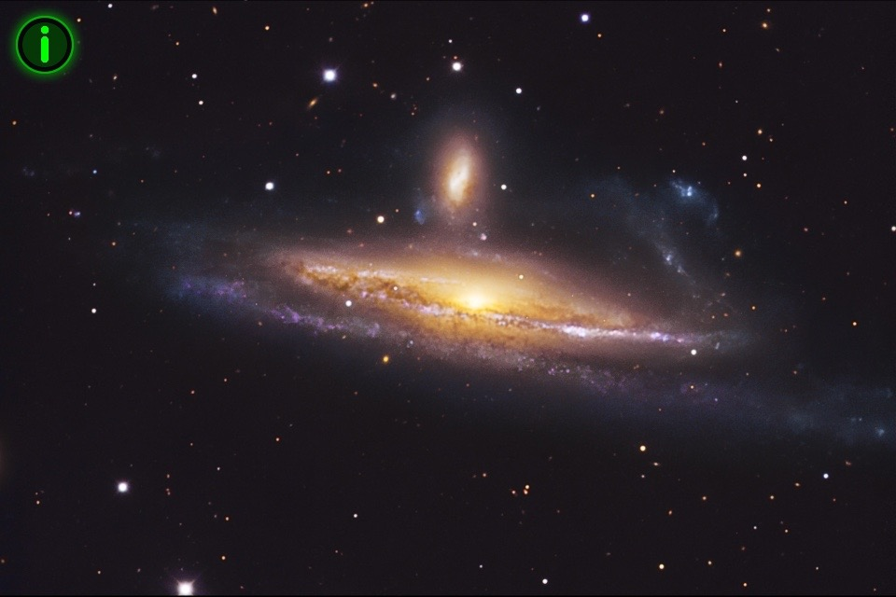
The Triduum has its cosmic dimension. The atoms that formed the complex molecules and amino acids in the sea have their origin in the birth and death of stars, the bonding of hydrogen and formation of helium. Helium bonded to form carbon, called the "love atom," that wants to bond with everything; life as we know it is carbon-based. Birth and death of stars - a cosmic furnace of the Paschal Mystery - is the infancy of 14 billion years ago, growing older still in an expanding universe, where galaxies are flying apart from each other and colliding as well (photo at right); our own galaxy is moving at 1.3 million miles per hour! Some day, we will look up into the night sky and see only darkness, devoid of twinkling stars. It will be a "Good Friday Universe." New Life? The cosmic foundation for this rhythm is inexplicable; some of us call it "God."
The next time you see stars at night, stop and meditate on their momentary existence; be open to wonder and awe. After all, we are dust from the stars. "From dust to dust you shall return" (Ash Wednesday).
I am on my way to the ocean shore a few blocks away and will look at the waves and breathe in its salty air. The sea reminds me once more of the Paschal Mystery. Now you know why we use water for baptism.
Happy Easter!

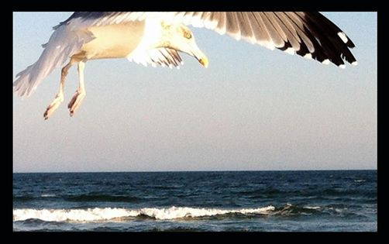

A contemporary expression of the resurrection

